OIP-N40E Bridge

User Manual - English

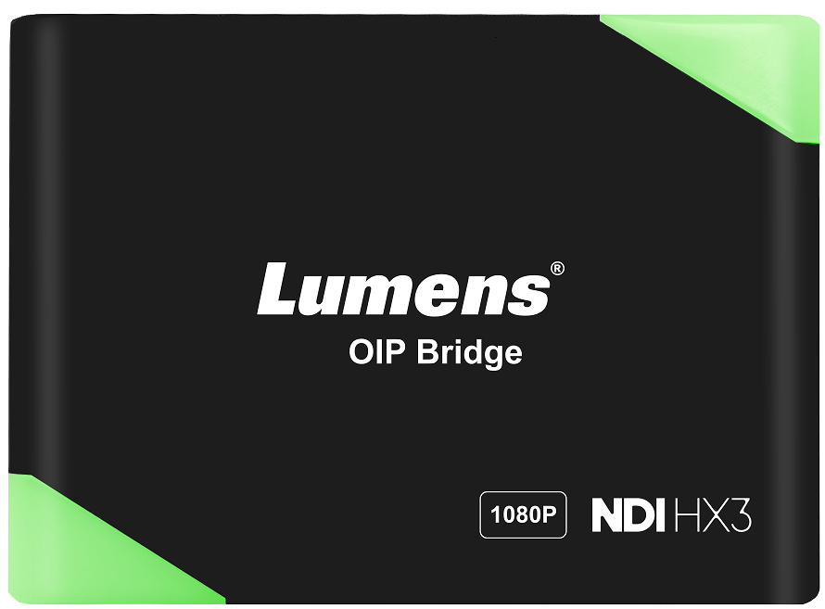

[Important]
To download the latest version of Quick Start Guide, multilingual user manual, software, or driver, etc., please visit Lumens
https://www.MyLumens.com/support

Table of Contents

Chapter 1 Package Contents 2
Chapter 2 Product Installation 3
2.1 I/O Interface 3
2.2 Product Installation 3
2.3 Description of Indicator Display 4
Chapter 3 Product Operation 5
3.1 Operating using the rocker switch 5
3.2 Operate via webpages 5
Chapter 4 Product Application and Connection 6
4.1 HDMI Signal Source Transmission Network 6
4.2 USB Network Camera Extension (OIP-N40E/OIP-N60D required) 6
Chapter 5 Setting Menu 8
Chapter 6 Webpage Interface 9
6.1 Connecting to Internet 9
6.2 Log into the webpage 9
6.3 Webpage Menu Description 10
Chapter 7 Troubleshooting 20
Chapter 8 Safety Instructions 21
Copyright Information 23

- Package Contents

OIP-N40E |  | USB 2.0 cable (1.8 M)  (Type A Type C) |  | Locking metal plate (x2)
 |  | 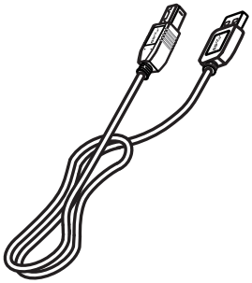 |  | 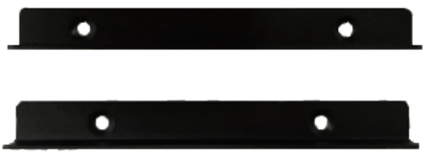
M3 metal plate screw (4x4)
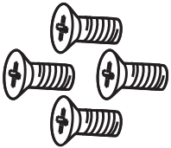

- Product Installation
  - I/O Interface
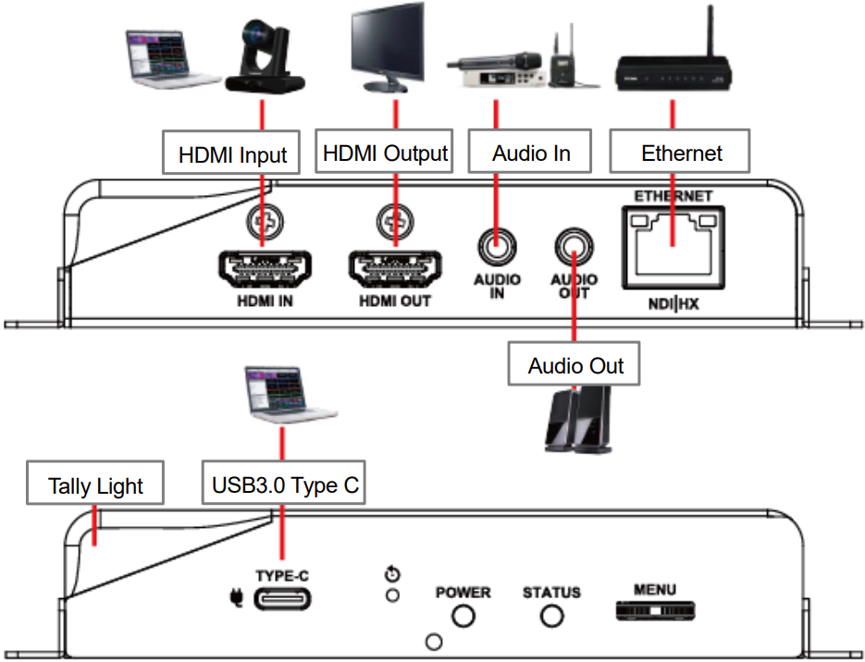

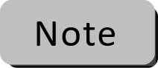 We recommended using high-performance USB-C cables (10Gbps or higher)
  - Product Installation
▪ Using the accessory metal plates
1. Lock the accessory metal plate with screws (M3 x 4) to the lock holes on both sides of the OIP Bridge | 2. Screw the metal plate to the desk or other surface as required.
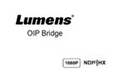  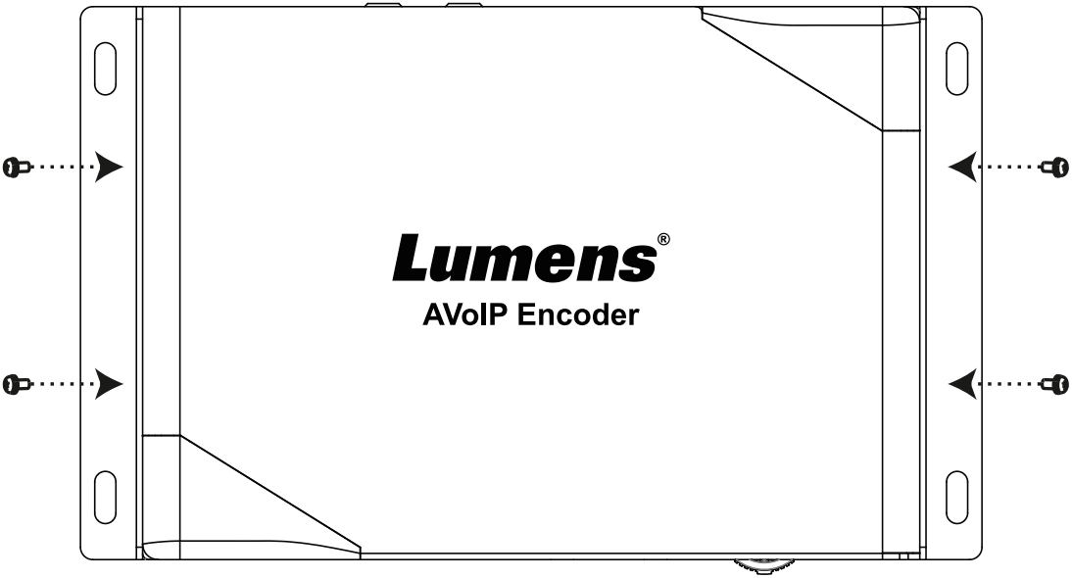 | 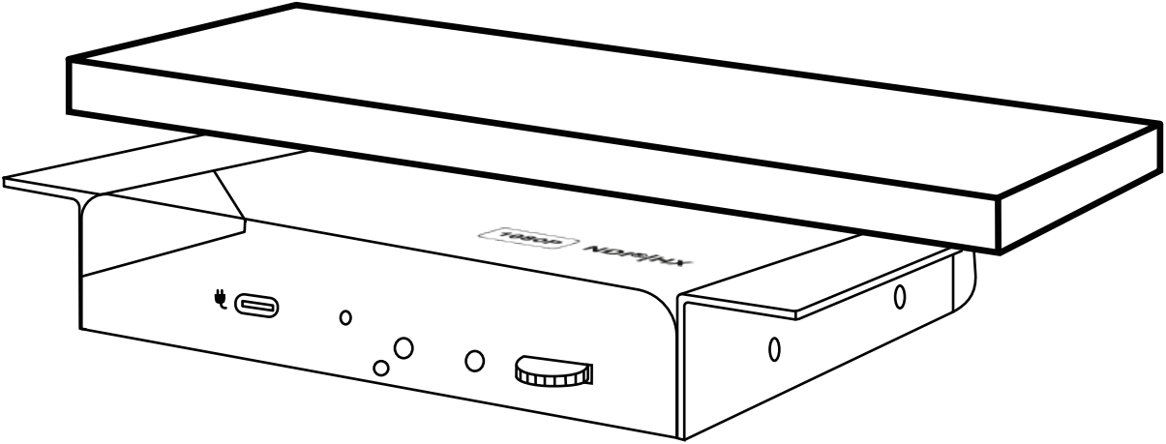
▪ Tripod mounting
The camera can be mounted on a 1/4”-20 UNC PTZ tripod deck by using the lock holes on the side for the tripod of OIP-N40E
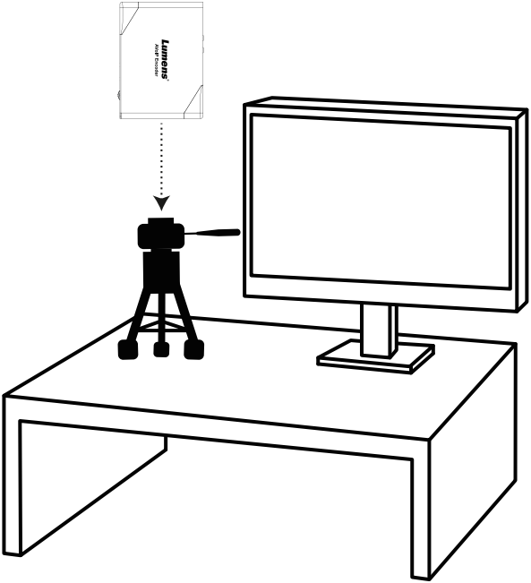
  - Description of Indicator Display
Power Status | Tally Status | Power | Standby | Tally
Startup in progress (initialization) | - | Red light | - | Flickering Red/Green light
In use | Signal | Red light | Green light | -
In use | No Signal | Red light | Green light | -
In use | Preview | Red light | Green light | Green light
In use | Program | Red light | Green light | Red light

- Product Operation

  - Operating using the rocker switch
Connect the HDMI OUT to the display, press the Menu dial to enter the OSD menu. Move the rocker switch to navigate the menu and adjust the parameters
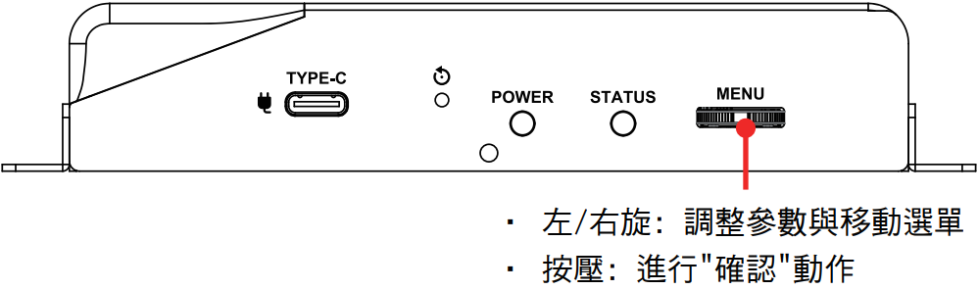
▪ Rotate: Adjust parameters and Navigate in the menu
▪ Press: Enter/ Confirm

  - Operate via webpages
(1) Confirm the IP address
Refer to 3.1Using the rocker switch, confirm the IP address in Status (If the OIP-N40E is directly connected to the computer, the default IP is 192.168.100.100. You need to manually set the computer's IP address in the same network segment.)
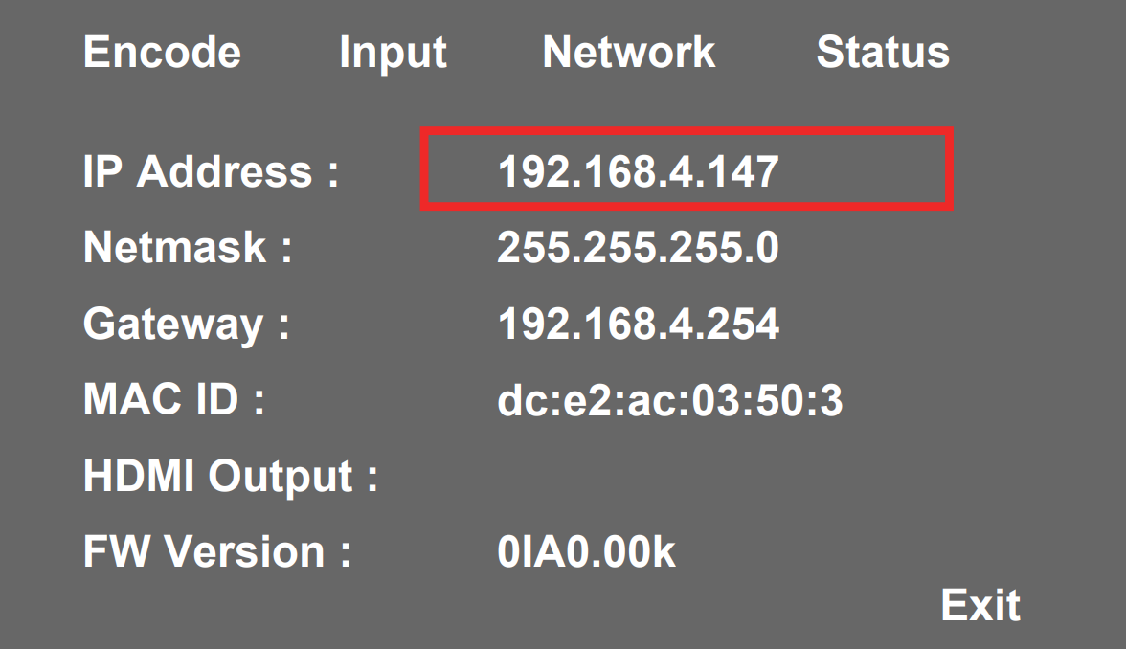
(2) Open the browser and input the IP address, e.g. 192.168.4.147, to access the login interface.
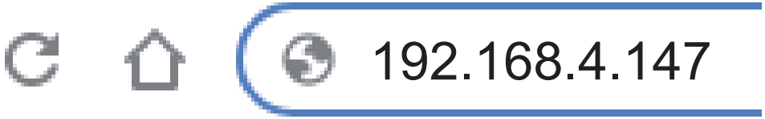
(3) Please enter the account/password to log in
▪ Account：admin
▪ Password：9999
- Product Application and Connection
  - Signal Source Transmission
OIP-N40E can convert IP signal to USB or USB signals to IP.
Note: When using a USB connection to the OIP, a USB 3.1 Gen2 (10Gbps) cable is required.

(1) Connection Method
▪ Connect the OIP-N40E and the computer to the network switch using network cables, so that you can access the OIP-N40E webpage for configuration.
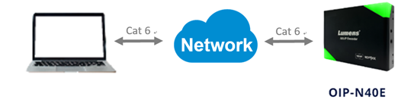

(2) USB Output (IP to USB)
Enable the Virtual USB Output to display the UVC image from an IP camera on a computer.
[System] - [Output] – [Virtual USB Output]
[Source] list > Connect camera > Press [Play] to display image
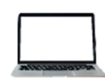
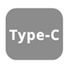
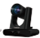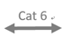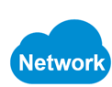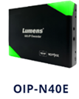

(3) HDMI Output Pass-though (HDMI / DP to HDMI )
Connect the HDMI or DP source to the OIP-N40E HDMI IN/USB-C port, then connect the OIP-N40E HDMI OUT port to a HDMI display, so that the image can pass-through.
[Stream] > [Source] > [Select HDMI / DP / Auto]
DP

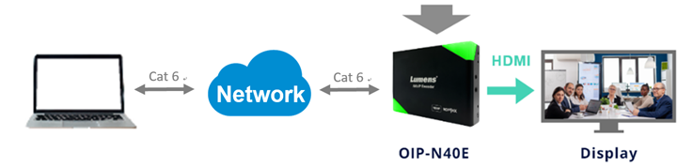
(4) Stream Output (HDMI to IP)
Connect the HDMI source to the OIP-N40E HDMI IN port, then output the stream using the selected streaming protocol.
[Stream] > [Stream Type] > [NDI / RTSP / RTMP / Dante]
[Stream] > [Source] > [Select HDMI source]
Dante

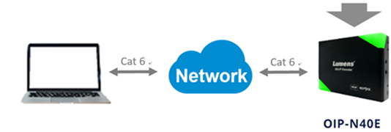
RTSP
NDI
RTMP

(5) Stream output (USB-C to IP)
Connect the DP supported computer to the OIP-N40E USB-C port, then output the stream using the selected streaming protocol.
[Stream] > [Stream Type] > [NDI / RTSP / RTMP / Dante]
[Stream] > [Source] > Select [DP source]
DP source
Dante

RTSP
NDI
RTMP

  - USB Camera Extension over network (OIP-N40E/OIP-N60D required)
OIP supports network bridging. Use the OIP-N40E with the OIP-N60D to extend the range of USB cameras over the local area network.
Note: When using a USB connection to the OIP, a USB 3.1 Gen2 (10Gbps) cable is required.

- USB Webcam extension
▪ Connect the OIP-N40E with the OIP-N60D in the Source list.
▪ Connect the USB camera to the OIP-N60D using a USB-A cable
▪ Connect a computer to the OIP-N40E using a USB-C cable.

OIP-N60D: [System] > [Output] > Enable [USB Extender] and [Virtual USB]
OIP-N40E: [System] > [Output] > Connect the OIP-N60D in the [Extender Source List]

The USB camera image will be output to the computer though the OIP-N40E’s USB output.

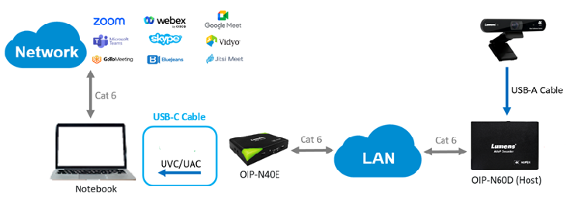

(2) USB Webcam extension + DP output
▪ Connect the OIP-N40E with the OIP-N60D in the Source list.
▪ Connect the USB camera to the OIP-N60D using a USB-A cable
▪ Connect a computer to the OIP-N40E using a USB-C cable

OIP-N60D: [System] > [Output] > Enable [USB Extender] and [Virtual USB]
OIP-N40E: [System] > [Output] > Connect the OIP-N60D in the [Extender Source List]
OIP-N40E: [Stream] > [Source]> [Select DP]
The computer can use the USB camera as the webcam and project the meeting live view to the HDMI display.

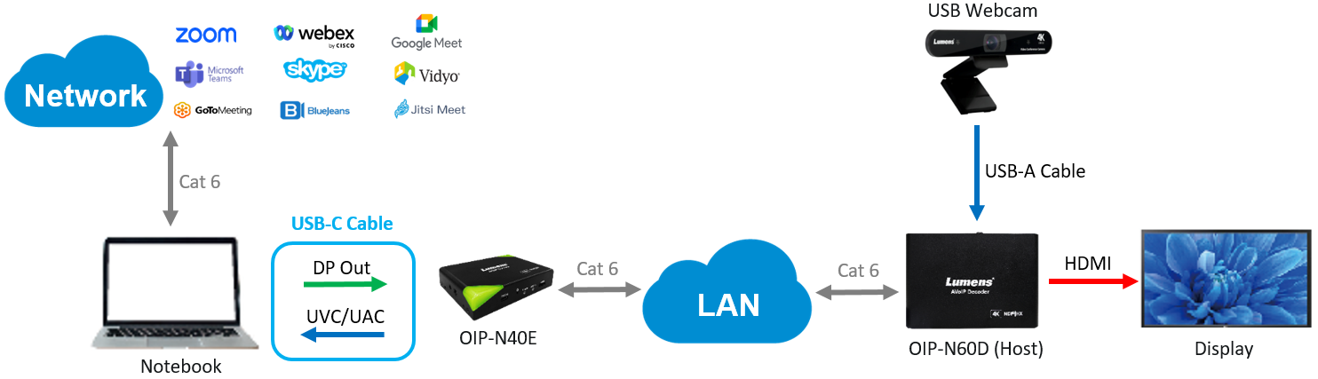

- Setting Menu
Using the rocker switch [Menu] enter the setting menu; the bold underlined values in the following table are defaults.

1st Level  Major Items | 2nd Level  Minor Items | 3rd Level  Adjustment Values | Function Descriptions
Encode | Stream Type | NDI HX/ RTSP / RTMP / RTMPS | Select the stream type
Input | HDMI-in From | Auto / HDMI/ DP | Select the input source
Network | IP Mode | Static/ DHCP/ Auto | Dynamic Host Configuration
Network | IP Address | 192.168.100.100 | Configurable when set to Static
Network | Subnet mask (Netmask) | 255.255.255.0 | Configurable when set to Static
Network | Gateway | 192.168.100.254 | Configurable when set to Static
Status | - | - | Display the current machine status
- Webpage Interface
  - Connecting to Internet
Two common connection methods are shown below
1. Connecting via switch or router
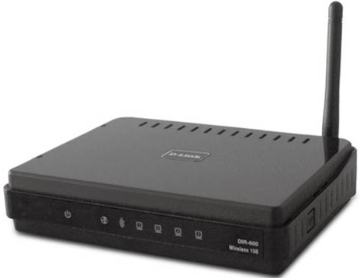
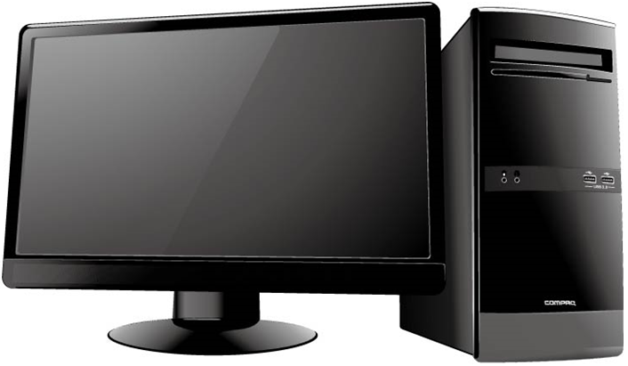
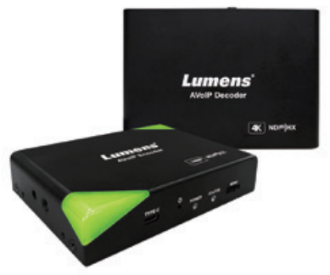
Network cable
Network cable

Switch or router
OIP Bridge
Computer

2. To connect directly using a network cable, the IP address of the keyboard/computer should be changed and set as the same network segment.
Network cable

Computer
OIP Bridge

  - Log into the webpage
  - Open the browser, and enter the URL of OIP-N in the IP address bar
E.g.: http://192.168.4.147
  - Enter the administrator’s account and password
For a first-time login, please refer to 6.3.8 System- User to change the default password
Lumens OIP Bridge
- Account: admin
- Password: 9999 (Default)

  - Webpage Menu Description
    - Dashboard
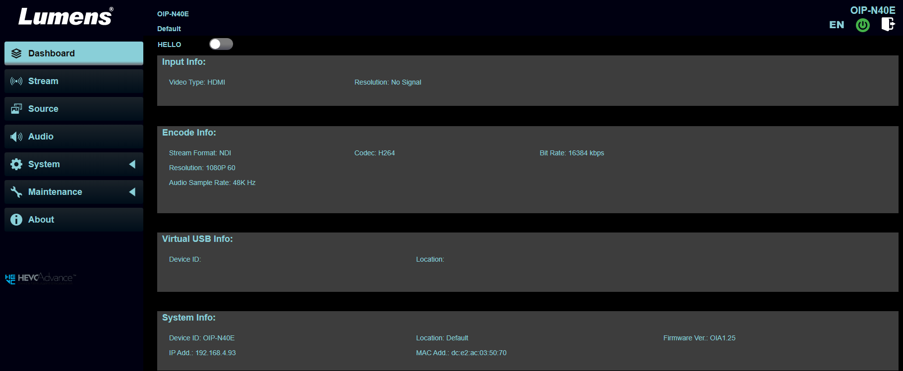
Function Descriptions
Display input, encode, virtual USB and system related information
HELLO: Enable this button to make the indicator light on the unit blink for one minute. It will then automatically turn off.

    - Stream
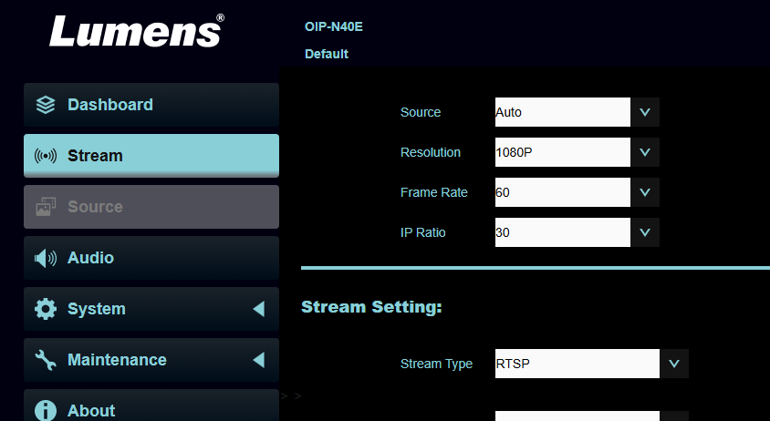
1
2
3
4

5

No | Item | Description
1 | Source | Auto / HDMI / DP
2 | Resolution | 1080P / 720P
3 | Frame Rate | 60 / 59.94 /50 /30 / 29.97 / 25
4 | IP Ratio | 30
5 | Stream Type | NDI HX / RTSP / RTMP / RTMPS / Dante AV-H
5.1 | NDI HX | 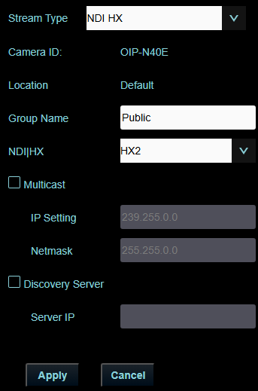  ▪ Camera ID/Location: Name/Location display according to System Output settings  ▪ Group Name: The group name can be modified here and set with Access Manager - Receive in NDI Tool  ▪ NDI|HX: HX2/HX3 is supported  ▪ Multicast: Enable/Disable Multicast  It is suggested to enable Multicast when the number of users online watching the live image simultaneously is more than 4  ▪ Discovery Server: Discovery service. Check to enter the Server IP address
5.2 | RTSP/ RTSPS | 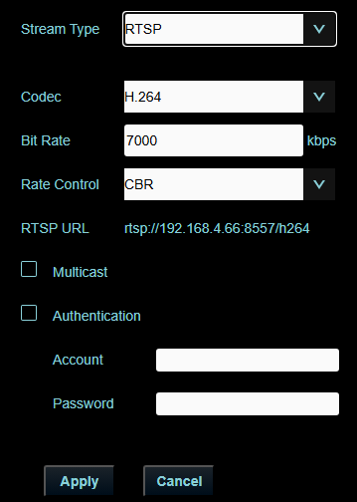  ▪ Codec (Encode Format): H.264/HEVC  RTMP/ RTMPS only support H.264  ▪ Bit Rate: Setting range 2,000 ~ 20,000 kbps  ▪ Rate Control: CBR/VBR  ▪ RTSP URL: Output the image with RTSP URL  ▪ Multicast: Enable/Disable Multicast  When the number of users online watching the live image simultaneously is more than 4.  ▪ Authentication: Enable/Disable Username/Password Authentication  The username/password is the same as the webpage login password, please refer to 6.1.10 System- User to add/modify account information
5.3 | RTMP/RTMPS | 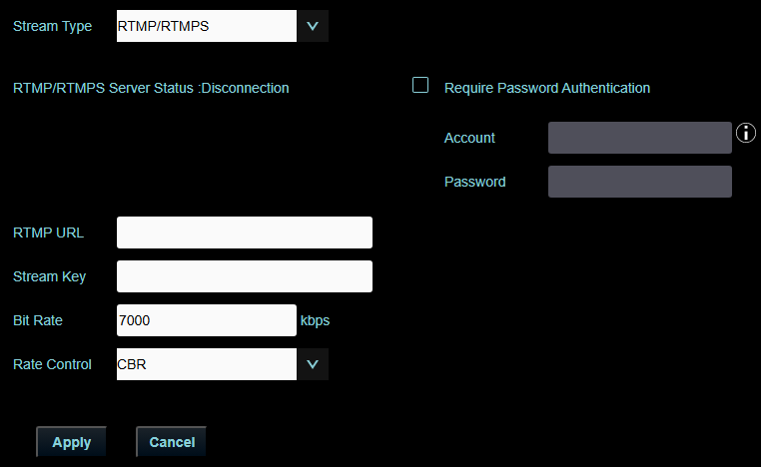  ▪ RTMP URL: Enter the RTMP URL  ▪ Stream Key: Enter the Stream Key  ▪Bit Rate: 2,000 ~ 20,000 kbps  ▪Rate Control: Choose from CBR / VBR  ▪ Required Password Authentication: Enable / Disable authentication
5.4 | Dante AV-H  (After activating the Dante license) | 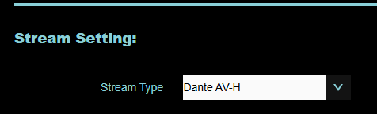  Choos Dante AV-H to output Dante

6.3.3 Source
< The source section can only be accessed when the Virtual USB in the System – Output section is enabled.>
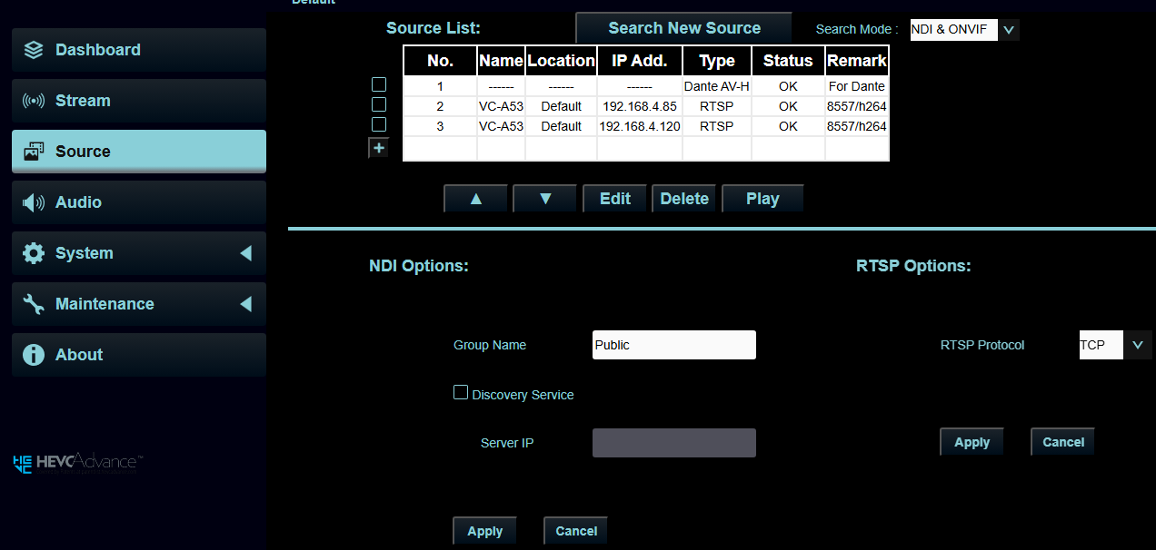
1
2
3
4

5

6

7

No | Item | Description
1 | Search New Source | Click to search for devices in the same network segment and display them in the list
2 | +Add | Manually add a device
3 | Search Mode | Search from NDI&ONVIF, only NDI, and only ONVIF
4 | Play | Select a device, click to play
5 | Group Name | The group name can be modified here and set with Access Manager - Receive in NDI Tool
6 | Discovery Service | Discovery service. Select to enter the Server IP address
7 | RTSP Options | Choose from TCP and UDP
Dante controller
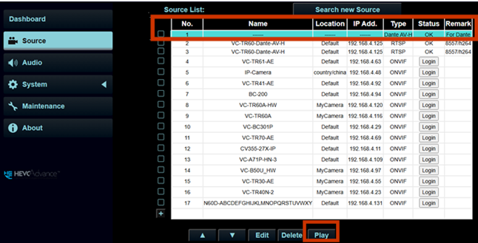

To ensure the unit OIP unit can be recognized by the Dante Controller after enabling the Dante function, please follow the steps below:
1. Access the unit’s web page
2. Navigate to the [Source] section
3. Select [Dante AV-H] as the source
4. Click [Play] to activate the stream
Remark: If the play button is not activated, the device will not be detected properly by the Dante Controller.
6.3.4 Audio
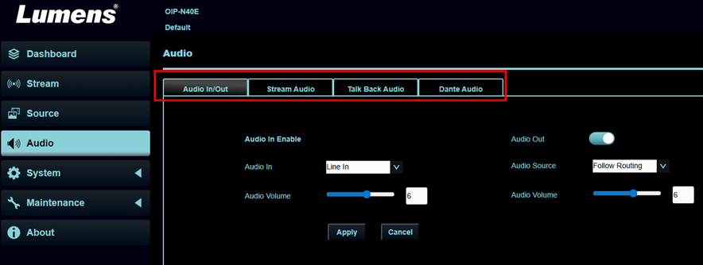
No | Item | Description
1 | Audio In / Out | ▪ Audio In: Select Line in or Mic in  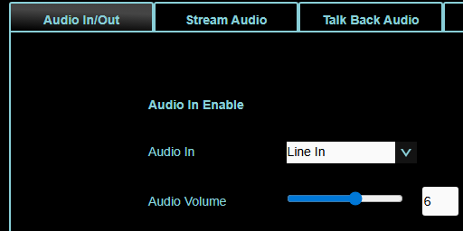  ▪ Audio Out: Enable or disable the audio output port.  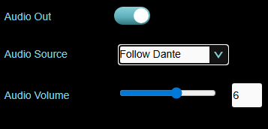  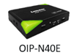    The 3.5 mm output port can be connected to devices such as earphones or speakers 3.5mm audio cable  ▪ Source of the Audio Output port:    - Follow Stream: Output the sound of the device you connected in the N40E Source section.  Follow Stream 3.5mm audio cable  (NDI / ONVIF)  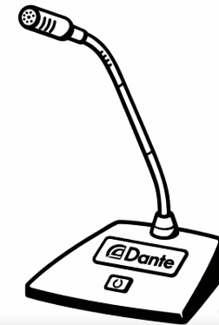  - Follow Dante: Output the sound from a Dante device you connected with Dante Controller.  Follow Dante 3.5mm audio cable  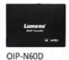  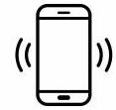  - Follow Routing: Output audio from the OIP-N60D’s audio input.  3.5mm audio cable Follow Routing  <The Follow Routing function can only be achieved by connecting the OIP-N60D and OIP-N40E using the Lumens Routing Switcher software.>  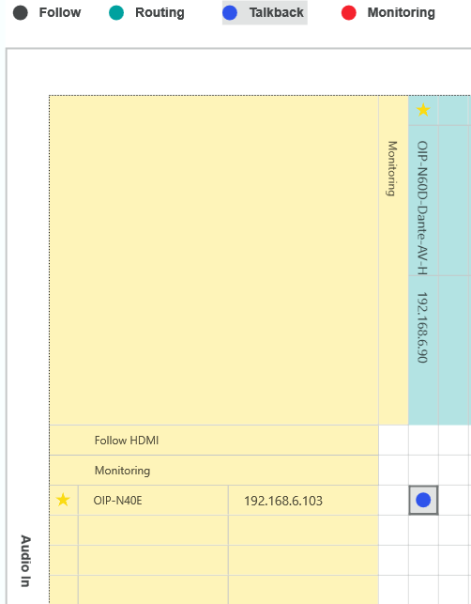  ▪ Audio Volume: 0~10
2 | Stream Audio | 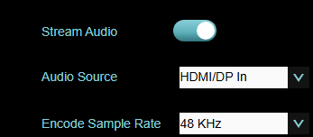  ▪ Stream Audio: Enable or disable audio output.  ▪ Audio Source for streaming: Select which audio input you want to output with streaming:  - HDMI / DP In: Outputs audio from the device connected to the HDMI IN or DP IN port.  HDMI In  - Audio In: Outputs audio from a device such as cellphone connected to the 3.5mm audio input on the N40E.  Audio In  - USB Audio: Outputs sound from a device such as a laptop connected via USB.  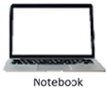  USB Audio  ▪ Encode Sample Rate: 48KHz  Audio Output Stream Type  Select the protocol used to transmit audio:  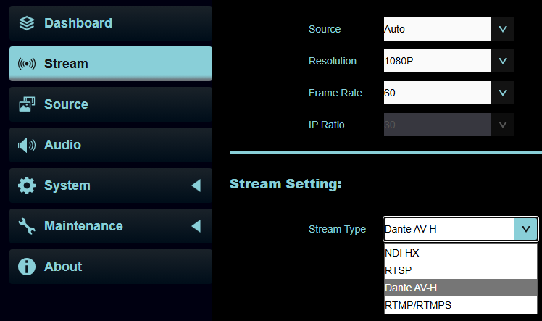  1. Dante AV-H  2. RTSP  3. NDI HX  4. RTMP / RTMPS  The selected audio source above in Stream Audio section will be transmitted through the output type you choose in the Stream Setting section.  Ex.    HDMI RTSP    Audio in Dante  USB Audio Dante
3 | Talk Back Audio | 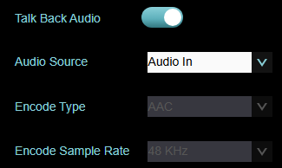  ▪ Talk Back Audio: Enable or disable Talk Back  After connecting the OIP-N60D and OIP-N40E using the Lumens Routing Switcher software (see the screenshot below), the Talk Back function enables two-way audio communication, allowing each device’s input to be routed to the other device’s output.  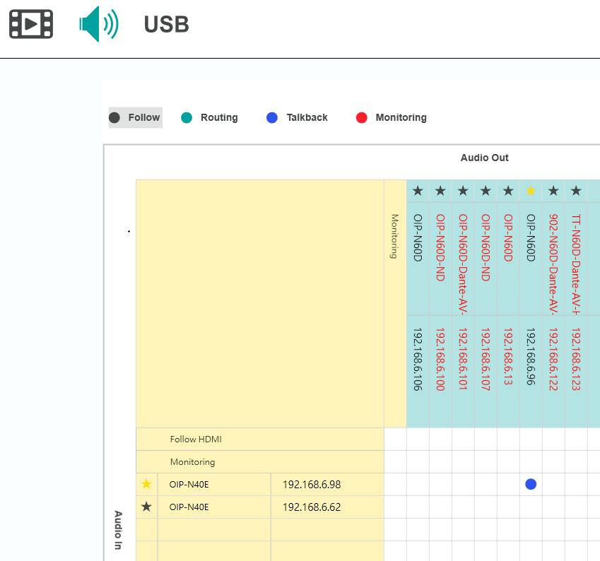  Audio In  Audio Out  Audio In  Audio Out  ▪ Audio Source:  - Audio in: Outputs audio from a device connected to the 3.5mm audio input on the N40E.  - USB Audio: Outputs sound from a device such as a laptop connected via USB.  ▪ Encode Type: AAC  ▪ Encode Sample Rate: 48KHz
4 | Dante Audio  (After activating the Dante license) | 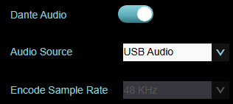  ▪ Dante Audio: Enable or disable Dante  ▪ Audio Source:  - HDMI / DP: Outputs audio from the device connected to the HDMI IN or DP IN port.  - Audio in: Outputs audio from a device connected to the 3.5mm audio input on the N40E.  - USB Audio: Outputs sound from a device such as a laptop connected via USB.  ▪ Encode Sample Rate: 48KHz
6.3.5 System- Output
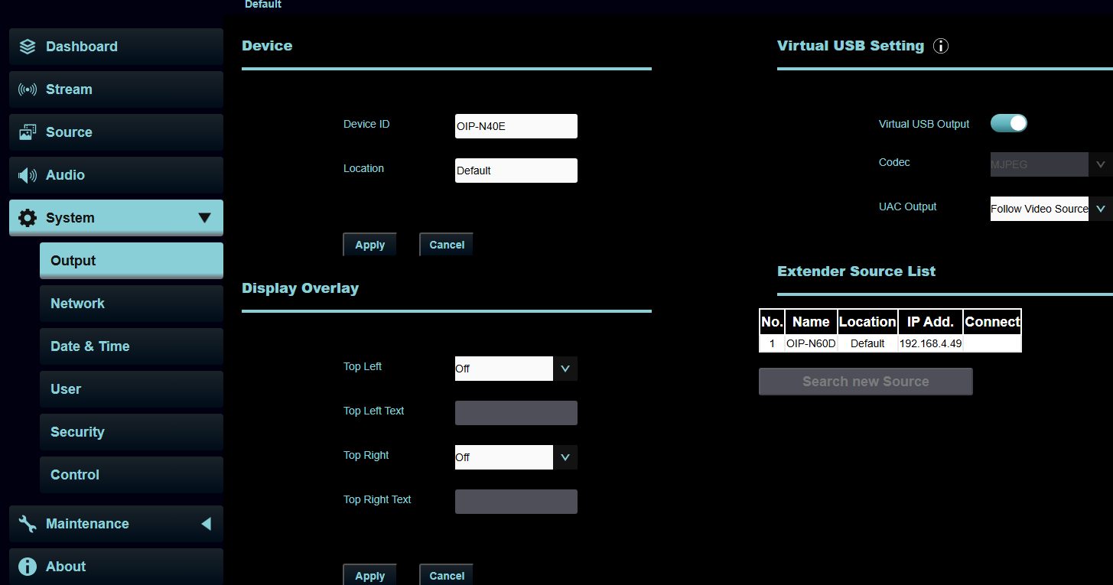
1
2
3
No | Item | Description
1 | Device ID/ Location | Device Name/Location  ▪ The name is limited to 1 - 12 characters  ▪ The location is limited to 1 - 11 characters  ▪ Please use uppercase and lowercase letters or numbers for characters. Special symbols such as “/” and “space” cannot be used  Modifying this field will modify the Onvif device name/location.
2 | Display Overlay | Customize the position of the “date and time”, or “custom content”, to display in the top left or top right corner of the output.
3 | Virtual USB Setting | Virtual USB output: Enable / Disable  Codec: MJPEG  UAC Output: OFF / Follow Video source / Follow Dante / Follow Routing
4 | Extender Source List | Display the available extender source devices in the network.

6.3.6 System- Network
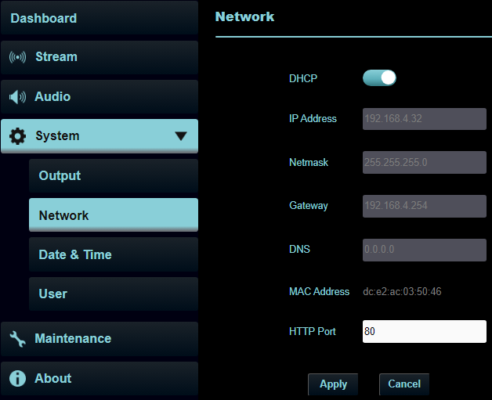
1
2
No | Item | Description
1 | DHCP | Ethernet setting for OIP Bridge. Change of setting is available when DHCP function is disabled.
2 | HTTP Port | Set HTTP port. The default Port value is 80
6.3.7 System- Date & Time
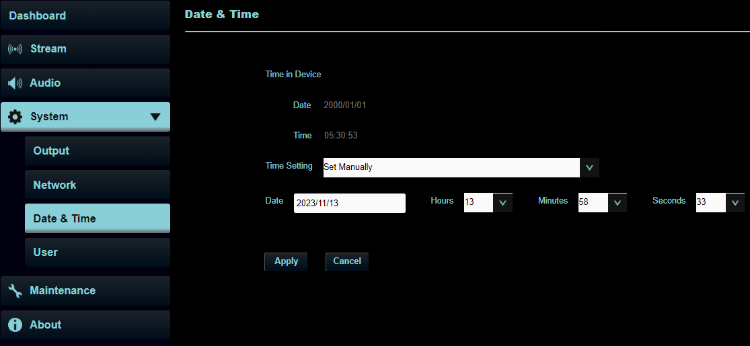
Function Descriptions
Display the current device/computer date and time, and set the display format and synchronization method
When Manually Set is selected for [Time Settings], Date & Time can be customized
6.3.8 System- User
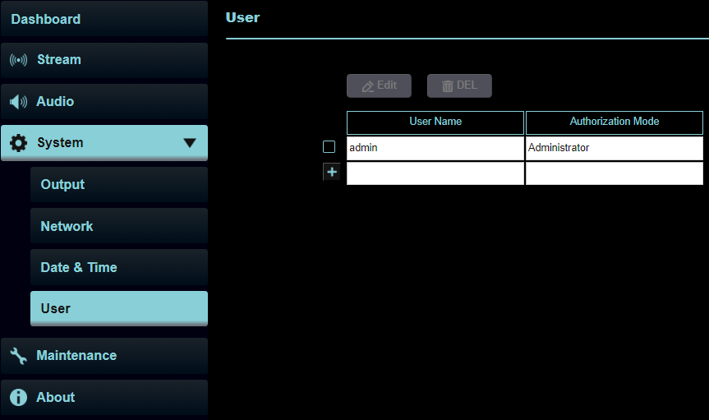
Function Descriptions
Add/Modify/Delete user account
- Supporting 4 - 32 characters for user name and password
- Please use uppercase and lowercase letters or numbers for characters. Special symbols or the underlined cannot be used
- Authentication Mode: Set the new account management permissions
User Type | Admin | Viewer
View | V | V
Setting/Account management | V | X
※When Factory Reset is executed, it will clear the user’s data
6.3.9 System - Security
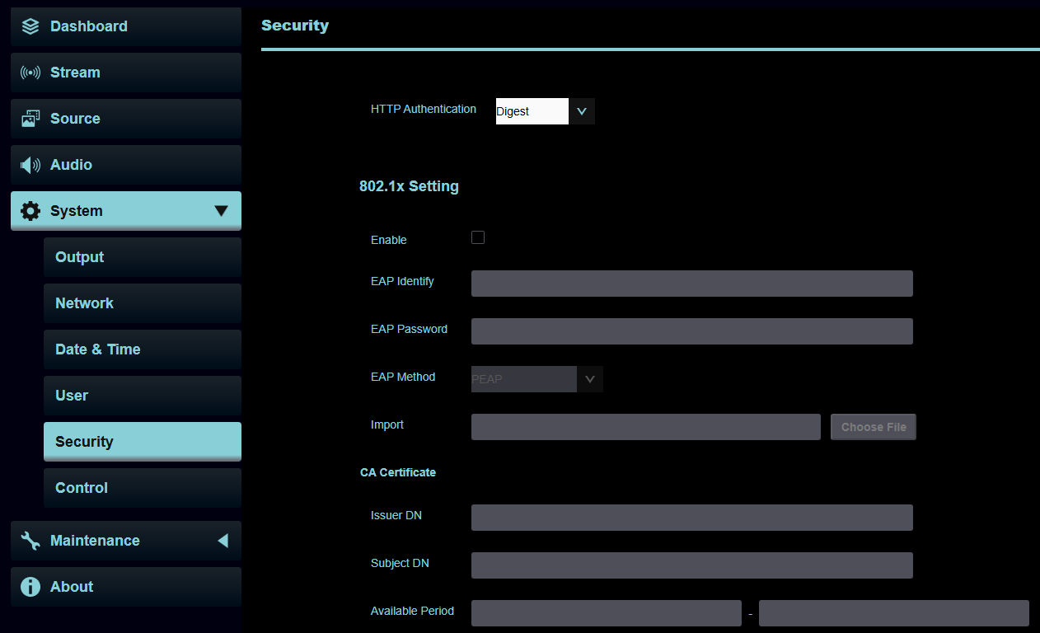
Function Descriptions
HTTP Authentication: Choose from Digest / Basic / Off
802.1x Setting: Enable / Disable
6.3.10 System - Settings
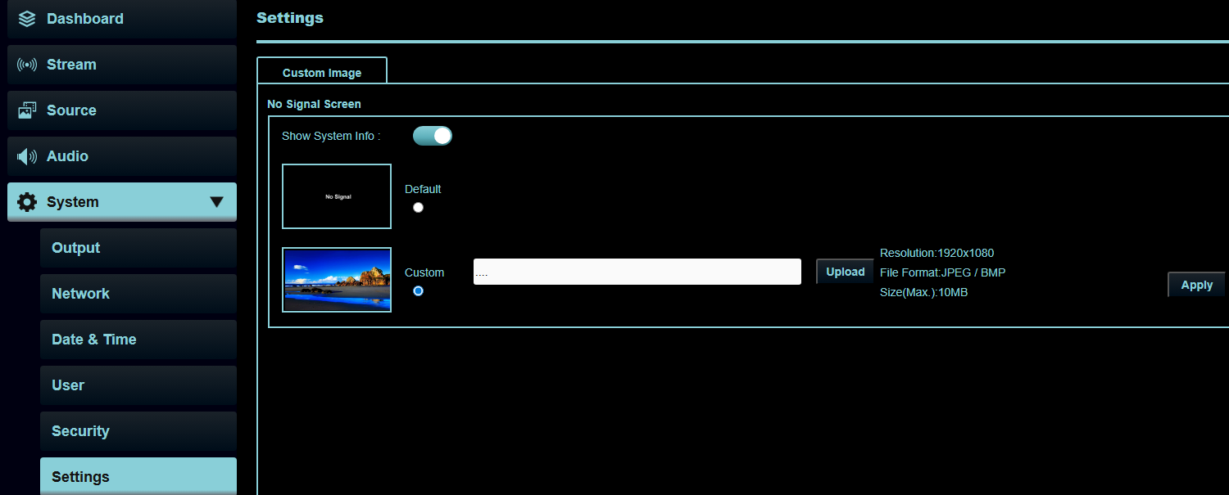
Functions Description
The user can upload a custom image (JPEG / BMP) to be displayed as the background when no signal is detected.
Select […] to locate your image, then click Upload and Apply to save it.

System Information: Enable this option to display product details such as the IP address and firmware version on the monitor.
6.3.11 Maintenance - Update
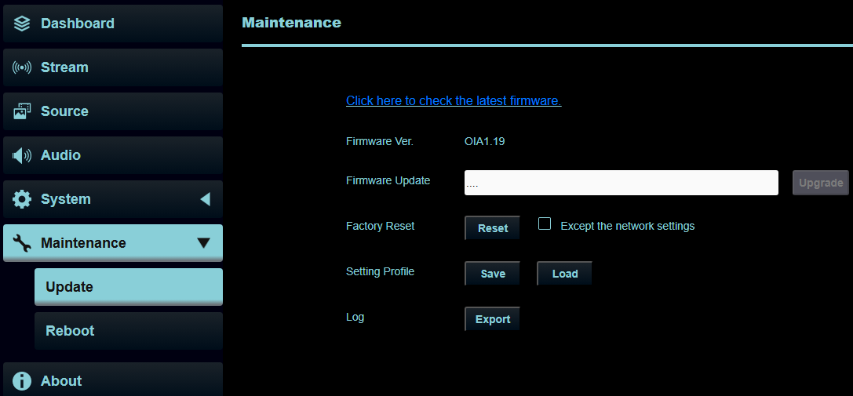
1
2
3
4
5
No | Item | Description
1 | Firmware link | Click on the link to the Lumens website and enter the model to obtain the latest firmware version information
2 | Firmware Update | Select the downloaded firmware file, and click [Upgrade] to update the firmware  Update takes about 2 - 3 minutes  Please do not operate or turn off the power of the device during the update to avoid firmware update failure
3 | Factory Reset | Reset all configurations to factory default settings
4 | Setting Profile | Save setup parameters. Users can save and load device setup parameters
5 | Log | Export the log file containing the records from the recent period.
6.3.12 Maintenance – Reboot
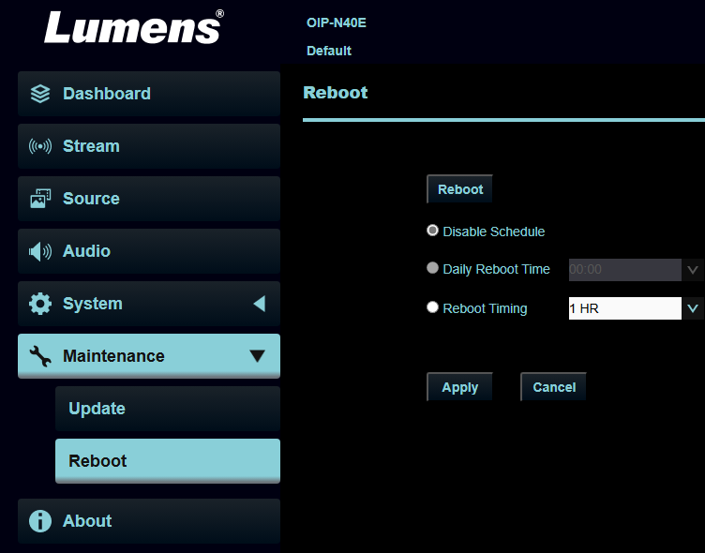
1
2
No | Item | Description
1 | Reboot | Click the button to reboot the unit
2 | Schedule Reboot | Disable Schedule: Turn off the schedule reboot function.  Daily Reboot Time: Set the exact time the unit will automatically reboot. (Can only be enabled when SNTP is selected in the Time Setting section.)  Reboot Timing: Set the reboot interval, from 1 to 24 hours.

6.3.13 About
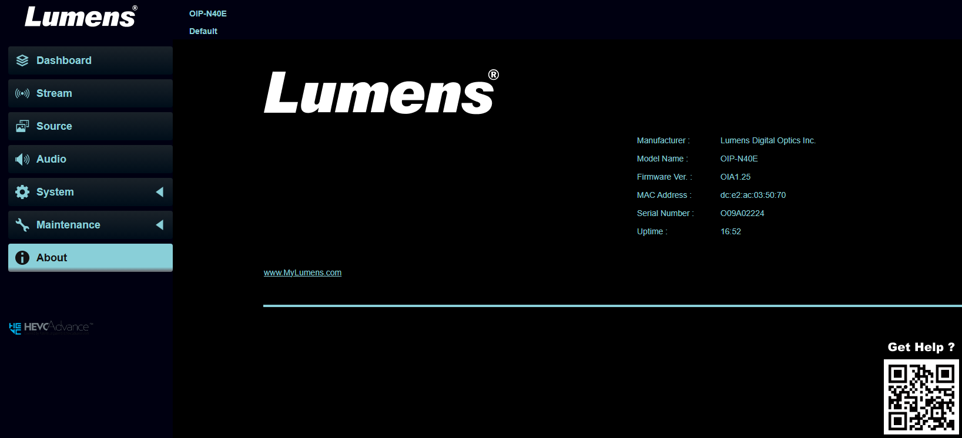
Function Descriptions
Display the firmware version, serial number, and other related information of the OIP Bridge
For technical support, please scan the QR Code at the bottom right for assistance
- Troubleshooting
This chapter describes problems you may encounter while using OIP Bridge. If you have questions, please refer to related chapters and follow all the suggested solutions. If the problem still occurs, please contact your distributor or the service center.
No. | Problems | Solutions
 | OIP-N40E cannot display the signal source screen | - Confirm that the cables are fully connected. Please refer to Chapter 4, Product Application and Connection  - Confirm that the input signal source resolution is 1080p or 720p  - Confirm that USB-C cables are recommended to use specifications with a transmission rate of 10Gbps or higher
 | OIP-N40E webpage USB extender cannot find OIP-N60D on the same network segment | - Confirm that the OIP-N60D has enabled the USB extender function  - Confirm that the management switch in the network has disabled the blocking of multicast packets
 | Recommended specifications for USB-C cables | Transfer rate of 10 Gbps or higher
 | Recommended Switch Configuration | When using OIP-N products with a network switch, it is recommended to configure the following settings:  1. Select a switch where every port supports 1Gbps transmission  2. Use a switch that supports QoS (Quality of Service) with 4 queues and strict priority; QoS should be enabled when both 100Mbps and 1Gbps devices exist in the same local network  4. Enable IGMP Snooping  5. It is recommended to choose a managed switch (Layer 2 or above)  6. It is advisable to disable EEE (Energy Efficient Ethernet) or similar power-saving features

- Safety Instructions
Always follow these safety instructions when setting up and using the product:
- Operation
  - Please use the product in the recommended operating environment, away from water or source of heat.
  - Do not place the product on a tilted or unstable trolley, stand or table.
  - Please clean the dust on the power plug prior to usage. Do not insert the product’s power plug into a multiplug to prevent sparks or a fire.
  - Do not block the slots and openings in the case of the product. They provide ventilation and prevent the product from overheating.
  - Do not open or remove covers, otherwise it may expose you to dangerous voltages and other hazards. Refer all servicing to licensed service personnel.
  - Unplug the product from the wall outlet and refer servicing to licensed service personnel when the following situations happen:
  - If the power cords are damaged or frayed.
  - If liquid is spilled into the product or the product has been exposed to rain or water.
- Installation
  - For security considerations, please make sure the standard mount you use is in line with UL or CE safety approbations and installed by technician personnel approved by agents.
- Storage
  - Do not place the product where the cord can be stepped on as this may result in fraying or damage to the lead or the plug.
  - Unplug this product during thunderstorms or if it is not going to be used for an extended period.
  - Do not place this product or accessories on top of vibrating equipment or heated objects.
- Cleaning
  - Disconnect all the cables prior to cleaning and wipe the surface with a dry cloth. Do not use alcohol or volatile solvents for cleaning.
- Batteries (for products or accessories with batteries)
  - When replacing batteries, please only use similar or the same type of batteries
  - When disposing of batteries or products, please adhere to the relevant instructions in your country or region for disposing of batteries or products

- Precautions
 | This symbol indicates that this equipment may contain dangerous voltage which could cause electric shock. Do not remove the cover (or back). No user-serviceable parts inside. Refer servicing to licensed service personnel. |  | This symbol indicates that there are important operating and maintenance instructions in this User Manual with this unit.

- FCC Warning
This equipment has been tested and found to comply with the limits for a Class B digital device, pursuant to part 15 of the FCC Rules. These limits are designed to provide reasonable protection against harmful interference in a residential installation. This equipment generates, uses and can radiate radio frequency energy and, if not installed and used in accordance with the instructions, may cause harmful interference to radio communications. However, there is no guarantee that interference will not occur in a particular installation. If this equipment does cause harmful interference to radio or television reception, which can be determined by turning the equipment off and on, the user is encouraged to try to correct the interference by one or more of the following measures:

- Reorient or relocate the receiving antenna.
- Increase the separation between the equipment and receiver.
- Connect the equipment into an outlet on a circuit different from that to which the receiver is connected.
- Consult the dealer or an experienced radio/TV technician for help.

Notice :
The changes or modifications not expressly approved by the party responsible for compliance could void the user’s authority to operate the equipment.
This equipment has been tested and found to comply with the limits for a Class B digital device, pursuant to part 15 of the FCC Rules. These limits are to provide reasonable protection from harmful interference in residential installations.

- IC Warning
This digital apparatus does not exceed the Class B limits for radio noise emissions
from digital apparatus as set out in the interference-causing equipment standard
entitled "Digital Apparatus," ICES-003 of Industry Canada.

Cet appareil numerique respecte les limites de bruits radioelectriques applicables aux appareils numeriques de Classe B prescrites dans la norme sur le material brouilleur: "Appareils Numeriques," NMB-003 edictee par l'Industrie.

Copyright Information
Copyrights © Lumens Digital Optics Inc. All rights reserved.

Lumens is a trademark that is currently being registered by Lumens Digital Optics Inc.

Copying, reproducing or transmitting this file is not allowed if a license is not provided by Lumens Digital Optics Inc. unless copying this file is for the purpose of backup after purchasing this product.

In order to keep improving the product, the information in this file is subject to change without prior notice.

To fully explain or describe how this product should be used, this manual may refer to names of other products or companies without any intention of infringement.

Disclaimer of warranties: Lumens Digital Optics Inc. is neither responsible for any possible technological, editorial errors or omissions, nor responsible for any incidental or related damages arising from providing this file, using, or operating this product.

